Human haemoglobin structure
Hemoglobin, also spelled haemoglobin, iron-containing protein in the blood of many animals—in the red blood cells (erythrocytes) of vertebrates—that transports oxygen to the tissues. Hemoglobin forms an unstable reversible bond with oxygen. In the oxygenated state, it is called oxyhemoglobin and is bright red; in the reduced state, it is purplish blue. Haemoglobin is a two-way respiratory carrier, transporting oxygen from the lungs to the tissues and facilitating the return transport of carbon dioxide. In the arterial circulation, haemoglobin has a high affinity for oxygen and a low affinity for carbon dioxide, organic phosphates, and hydrogen and chloride ions. In the venous circulation, these relative affinities are reversed.
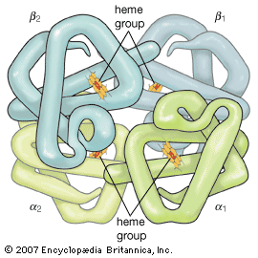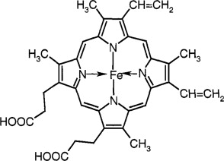
Heme Group

Hemoglobin is a protein made up of four polypeptide chains (α₁, α₂, β₁, and β₂) and it has a quaternary structure. There are 141 and 146 amino acids in the α and β chains of hemoglobin, respectively. In the alpha chain, the 87th residue is histidine and in the beta chain the 92nd residue is histidine. A heme group is attached to each of the four histidines. Thus, each subunit is linked covalently to a molecule of heme.
A heme group is composed of porphyrin (an organic ringlike compound) attached to an iron atom. These iron-porphyrin complexes coordinate oxygen molecules reversibly, an ability directly related to the role of hemoglobin in oxygen transport in the blood. It is the iron atom that binds oxygen as the blood travels between the lungs and the tissues.
Each polypeptide chain is made up of eight or nine alpha-helical segments and an equal number of nonhelical ones placed at the corners between them and at the ends of the chain. The helices are named A-H, starting from the amino acid terminus, and the nonhelical segments that lie between the helices are named AB, BC, CD, etc. The nonhelical segments at the ends of the chain are called NA at the amino terminus and HC at the carboxyl terminus.
Thus, hemoglobin binds four O₂ molecules. The two identical α chains and the two identical β chains are arranged tetrahedrally. These units are held together by hydrophobic interactions, hydrogen bonding, and ion pairs (salt bridges) between oppositely charged amino acid side chains.

